CAFS Forensic Science Conference 2026
Biographies of Speakers

Gregory Williams  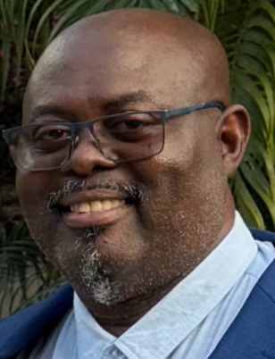 | Gregory J. Williams is a Founding Member, President, and Director of the Caribbean Association of Forensic Sciences (CAFS), a regional organization established to advance forensic science education, research collaboration, professional standards, and capacity building throughout the Caribbean.  A retired Police Inspector and senior forensic scientist of the Royal Police Force of Antigua and Barbuda, Mr. Williams brings over twenty-nine years of experience in forensic science, criminal investigation, and law enforcement leadership. During his policing career, he served as Head of the Forensic Department, where he led the modernization of crime scene investigation practices, strengthened evidence management procedures, and implemented structured forensic training programs that significantly improved investigative outcomes.  As CAFS President, Mr. Williams provides strategic leadership focused on regional integration, professional certification development, forensic education advancement, and international collaboration. Under his leadership, CAFS has promoted multidisciplinary partnerships among forensic practitioners, academics, law enforcement agencies, legal professionals, and students, while fostering a unified Caribbean voice within the global forensic science community.  Mr. Williams is currently an assistant lecturer at the University of the West Indies Mona Campus, teaching in MSc and postgraduate programs in forensic science. He serves as an adjunct lecturer in criminology and criminal justice at the Five Islands Campus in Antigua and Barbuda. He coordinates courses in Crime Scene Management, Crime Scene Reconstruction, Forensic Firearm Examination, and Expert Witness Testimony, mentoring the next generation of Caribbean forensic professionals.  He holds Bachelor’s and Master’s degrees in Forensic Science from the University of Staffordshire, United Kingdom, and a Postgraduate Diploma in University Teaching and Learning from the University of the West Indies. He is currently pursuing doctoral studies in Biochemistry, reflecting his commitment to integrating scientific research with forensic practice.  Mr. Williams maintains active professional affiliations with the International Association for Identification, the Chartered Society of Forensic Sciences, and the Institution of Fire Engineers. He is certified as a Crime Scene Instructor through the Regional Security System (RSS) and is qualified in fire investigation, fingerprint examination, forensic photography, and forensic engineering.  An internationally recognized forensic educator and practitioner, Mr. Williams has delivered more than 70 professional presentations and organized numerous regional conferences, symposia, and training initiatives designed to strengthen forensic science across small island developing states. He is an author and contributor to the Manual of Crime Scene Investigation (CRC Press, Taylor & Francis Group, 2022) and has supervised and supported multiple forensic science research projects throughout the Caribbean.  Through CAFS, Mr. Williams continues to champion scientific excellence, professional ethics, regional cooperation, and innovation in forensic science, positioning the Caribbean as an active contributor to global forensic practice and research.
Matthew Noedel  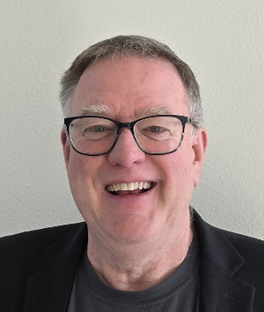 | Mr. Noedel is a Forensic Consultant specializing in scene reconstruction and bloodstain pattern analysis from the United States. He spent time working in Jamaica first in the examination of exhibits from the Tivoli event and then as a trainer and mentor for the forensic examiners working for Indecom. During that tenure, Mr. Noedel worked closely with the firearm examiners employed at the Institute of Forensic Science and Legal Medicine as well as the primary scene responders from Indecom. Mr. Noedel is a certified firearm examiner by the Association of Firearm and Tool Mark Examiners and a Past President of the Association for Crime Scene Reconstruction.
Dr. Maria Cuellar  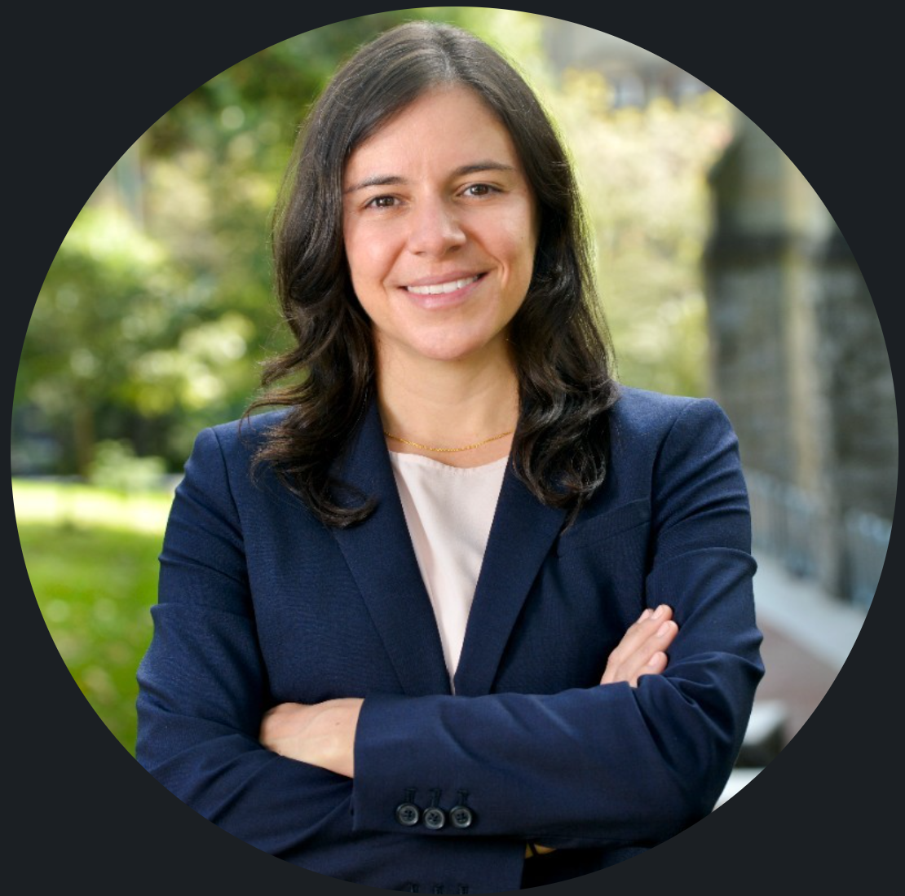 | Maria Cuellar, PhD is an Assistant Professor at the University of Pennsylvania with joint appointments in the Department of Criminology and the Department of Statistics and Data Science, and a secondary appointment in Biostatistics, Epidemiology, and Informatics. Her research lies at the intersection of statistics and the law. She studies the statistical foundations of forensic science, focusing on the validity, reliability, and fairness of disciplines such as fingerprint, toolmark, and facial recognition analysis, and develops methods to quantify uncertainty in forensic conclusions. Dr. Cuellar frequently serves as an expert witness in criminal trials and works to improve the scientific rigor of forensic evidence in the justice system.
Mya Davidson  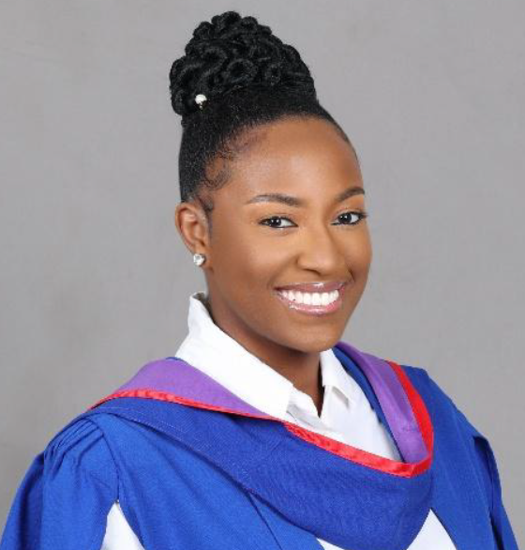 | Mya Davidson recently graduated from the University of the West Indies, Mona with a Master’s degree in Forensic Science, specializing in Pathology. She has always had a strong interest in forensic investigation and understanding the human body.  She has volunteered and interned at various institutions and gained practical exposure to autopsies, embalming and exhumation and refined her skills in confidentiality and ethics. In addition to her academic pursuits, she served as Assistant Treasurer for the Forensic Science Student Association and has a certification in ISO/IEC 17025:2017 General requirements for Testing & Calibration Laboratories, demonstrating leadership and active interest in the forensic science community.  At this Forensic Science Conference 2026, Mya Davidson will present on “Knowledge and Awareness of Forensic Odontology Among Dentists in Jamaica” to highlight its importance in modern forensic investigations and professional practice.
Zyrelle Williams  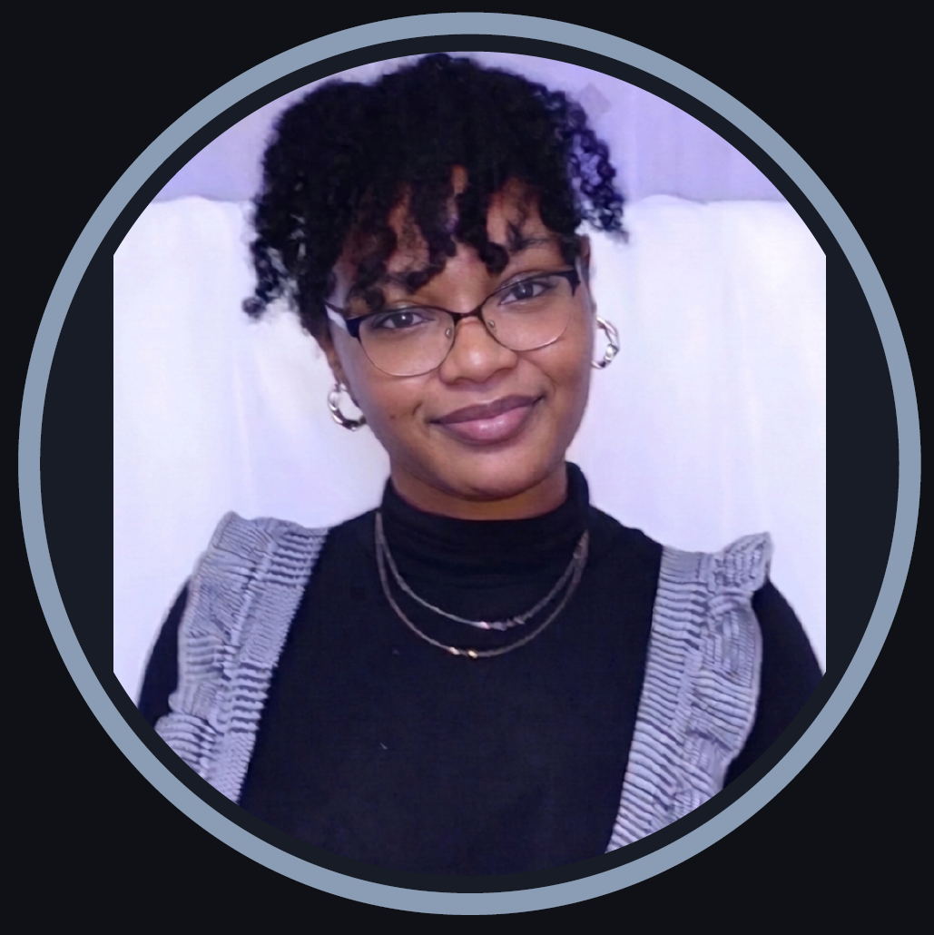 | Zyrelle Williams is a Grenadian forensic psychology researcher and emerging advocate for criminal justice reform in the Caribbean. Her academic journey reflects her passion for understanding human behavior and justice. She earned an Associate's Degree in Social Sciences from T.A. Marryshow Community College before going on to complete a Bachelor of Science (Honours) in Forensic Psychology from Atlantic International University.  She has further strengthened her expertise through a Professional Accredited Forensic Psychology Diploma and a micro-certificate in Forensic Psychology from the Sherlock Institute of Forensic Science, India, where she also completed an internship in Forensic Science and Criminal Investigation. Her thesis, Investigating the Role and Application of Forensic Psychology in the Grenadian Criminal Justice System, represents the first empirical study of its kind in Grenada and forms the basis of today's presentation. Zyrelle is committed to ongoing professional development, regularly engaging with regional and international forensic science events and seminars, and has also participated in training on responding to anger and rage in child neurodevelopment contexts. Beyond her academic pursuits, Zyrelle has volunteered with the Grenada Red Cross Society and served as Registration Manager for a UNICEF Gender-Based Violence workshop, reflecting her broader commitment to community service and advocacy for vulnerable populations. She is passionate about bridging the gap between law, psychology, and community well-being, and is committed to supporting a justice system that rehabilitates, heals, and upholds the dignity of all persons.
Kodye Boyd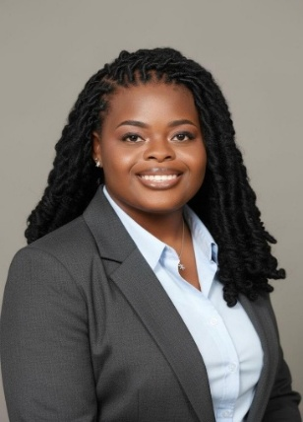 | Miss Kodye Boyd is a recent master’s graduate of the University of the West Indies, Mona. Specializing in Forensic Molecular Biology, she also holds a Bachelor’s degree in Biochemistry with a minor in Economics. During her program, she obtained a strong background in crime scene analysis, including fingerprinting, reconstruction, and evaluation of biological evidence. Her master’s research evaluated fingerprint powders on different surfaces for application at crime scenes in Jamaica, which she will be presenting today. Kodye is passionate about the evolution of forensic science and dedicated to preserving the longevity of forensic evidence to help solve crimes efficiently.
Na’jarrea Bell  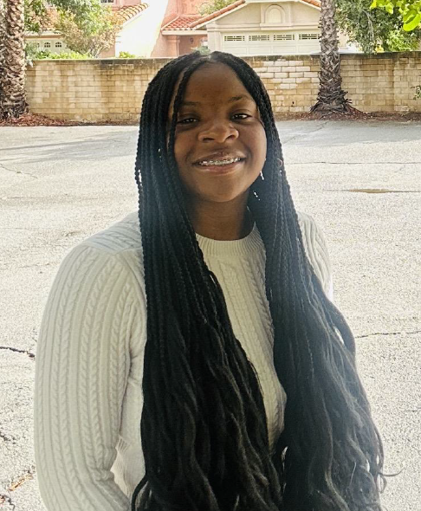 | Na’jarrea Bell is a third year undergraduate student at California State University San Marcos (CSUSM), majoring in Criminology and Justice Studies. She wishes to help people, understand human behavior, and make a difference. She grew up in foster care starting at nine years old, and those experiences shaped her strength, independence, and determination to create a better future for others. She has made Dean’s List in all three years as an undergraduate student and is a member of the Tau Sigma Honor Society at CSUSM. She earned an Associate Degree in Administration of Justice from Chaffey College and is expected to graduate from CSUSM in May 2027. As the first person in her family to earn a college degree, she takes great pride in her educational journey and accomplishments. She has also participated in leadership development opportunities through the Student Leadership and Involvement Center (SLIC) at CSUSM. She is CPR certified and holds a California Guard Card, reflecting her commitment to service, responsibility, and professional development.  Outside of school, she works full time while balancing leadership opportunities and volunteering. Na’jarrea has worked on public policy with California Youth Connection Foster Youth and frequently volunteers with Interfaith, a nonprofit that serves individuals  and families in need. She describes herself as hardworking, compassionate, determined, and goal oriented. She takes pride in being someone who genuinely cares about others and wants to make a positive impact on her community. In the future, she hopes to continue helping others through nonprofit service and a career in criminal justice. She hopes to one day become an FBI profiler.
Claudette Thompson  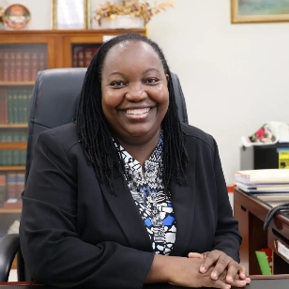 | Claudette Thompson, is the second female Director of Public Prosecutions for the island of Jamaica appointed in October 2025. She hails from the verdant parish of St. Ann.  She holds a Bachelor of Science degree in International Relations and Politics from the University of the West Indies Mona and gained her Bachelor of Laws degree from the University of Wolverhampton in 2002. She later obtained her Certificate in Legal Education from the Norman Manley Law School in 2004.  Upon graduating from law school, Ms. Thompson began her legal sojourn as Clerk of Court in St. Ann, a position she held until April 2007. She then entered the realm of prosecuting in 2007, as an Assistant Crown Counsel in the Office of the Director of Public Prosecutions (ODPP).  Since entering the ODPP, Ms. Thompson has held the positions of Crown Counsel, Assistant Director of Public Prosecutions, Deputy Director of Public Prosecutions and since January 2017, she elevated a Senior Deputy Director of Public Prosecutions.  Ms. Thompson has a passion for prosecuting and absolutely enjoys sharing her knowledge by making presentations to colleagues and other officers of the law.
Dr. Stephen Morley  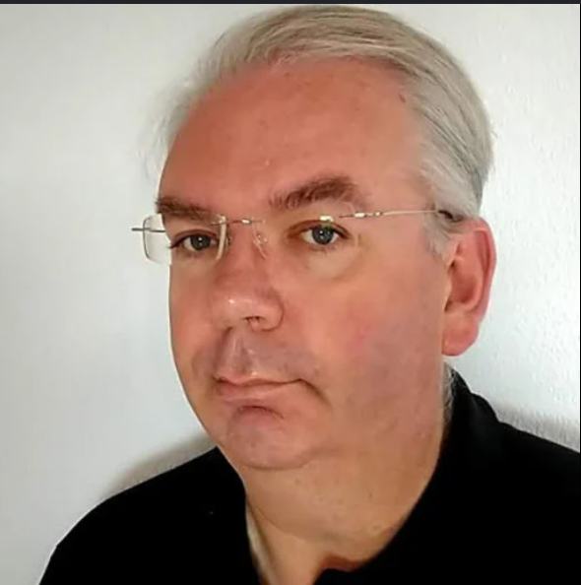 | Dr Morley is a Consultant Chemical Pathologist and Forensic Toxicologist at University Hospitals Leicester, where he leads clinical and forensic toxicology services. He trained at King’s College Hospital London, he qualified in 1993 before specialising in clinical biochemistry, analytical toxicology and post-mortem toxicology. His expertise includes poisoning management, therapeutic drug monitoring, forensic toxicology, coronial investigations and medico-legal reporting. He has contributed to numerous UK guidelines including the Royal College of Pathologists guidance on drug-related autopsies and has produced over 50 thousand coroners’ toxicology reports. His 70 publications cover post-mortem toxicology, toxic substances, drug misuse and laboratory diagnostics within forensic medicine and clinical toxicology across hospitals, universities and forensic pathology practice.
Dr. Sherika Whitelocke-Ballingsingh  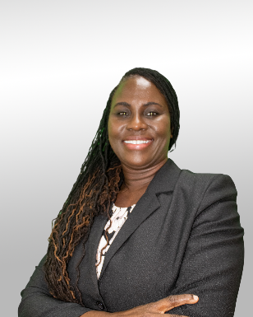 | Sherika Whitelocke-Ballingsingh serves as the Poison Information Coordinator for the Caribbean Poison Information Network, situated at the University of Technology, Jamaica. With over two decades of experience in public health, she is a Public Health Inspector by training. Her expertise spans international public health, medical toxicology, and education and training. She contributes to both public sector and academic institutions, with her research and professional background largely centered on chemical poisoning. Driven by a commitment to public health, she is passionate about safeguarding vulnerable populations from poisoning and is a strong proponent of policies aimed at protecting human health from toxic exposure across Jamaica and the wider Caribbean.
Danda Augustin  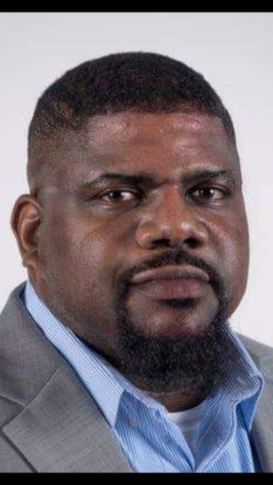 | Danda Augustin is a Senior Fire Investigator with EFI Global Inc. working primarily out of the northwest United States. Mr. Augustin has over a decade of experience in the fire service and fire investigation. He holds a Bachelor of Science in Fire, Arson and Explosion Investigation from Eastern Kentucky University.  His certifications include Certified Fire Investigator, Certified Fire Investigator Instructor, Certified Vehicle Fire Investigator, Certified Fire Inspector 1, Certified Plans Examiner, Certified Marine Investigator and Evidence Collection Technician.  At this conference he will discuss the concept of lessons learned and its benefits to public safety in the Caribbean.  Outside of work, he enjoys playing dominoes and cricket.
Roxann Sommerville-Rhoden  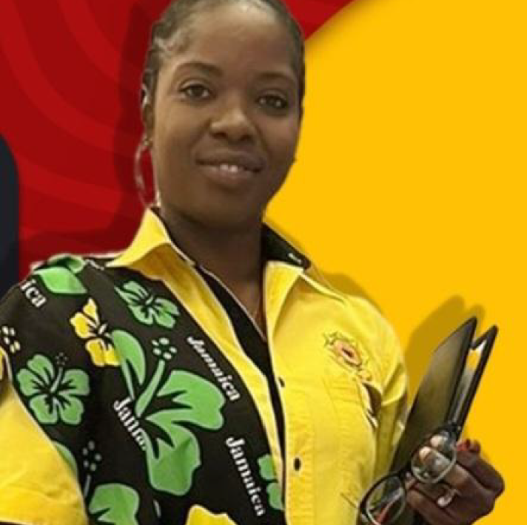 | Roxann Sommerville-Rhoden is a distinguished public servant whose life reflects unwavering resilience, disciplined leadership, and a deep commitment to national and community development. A wife, mother, Firefighter, Fire Prevention Officer, Training Instructor, and community-driven HR Consultant, she embodies the spirit of service in every sphere of her life.  Her passion for human development was ignited during her formative years and strengthened through her voluntary work with the HEART/NSTA Trust. As an interviewer, mentor, and youth advocate supporting the Summer HOPE Programme, she has helped young Jamaicans unlock their potential and pursue meaningful career paths. This work inspired her evolution into an HR Consultant grounded in service, empathy, and people-centered leadership.  Roxann’s foundation in discipline and leadership began long before her professional career. During her years at St. Mary High School, she was an active member of the Jamaica Combined Cadet Force, where she developed the values of teamwork, responsibility, and national pride. She also excelled in sports, becoming a member of the first female football team at St. Mary High School, while also participating in netball and athletics. Despite her demanding extracurricular activities, she consistently maintained strong academic performance, an early demonstration of her drive, balance, and determination to excel.  Her professional journey began at LIME (Cable & Wireless Jamaica Ltd), where she spent five years building a solid foundation in leadership, customer service excellence, and resource management. Her outstanding performance earned her multiple Employee of the Month awards and positioned her for greater national service.  In 2016, Roxann transitioned into public service as a firefighter with the Jamaica Fire Brigade. She has since become a respected firefighter in emergency response and safety education, holding advanced NVQ-J Level 5 certifications in Instruction and Delivery and Human Resource Management. As a Training Instructor and Fire Prevention Officer, she empowers personnel and communities through technical training, safety awareness, and proactive risk-reduction strategies.  Her skills and experience extend internationally. Roxann proudly represented Jamaica at the China Aid Emergency Search and Rescue Seminar in Beijing and is trained in high-risk operations including collapsed structure rescue and confined space rescue, skills that reflect her courage, precision, and commitment to saving lives.  Academically, she is entering her third year of pursuing a Bachelor of Science in Forensic Science at the Caribbean Maritime University, where she positioned herself early as the only student in her cohort named to the Dean’s Honour Roll in her first year. Her academic focus and operational experience fuel her long-term professional aspiration: to become a Fire Investigator within the Jamaica Fire Brigade, integrating forensic science with firefighting and prevention to strengthen national fire investigation capacity.  Beyond her professional and academic achievements, Roxann remains deeply committed to community upliftment. She has served with the St. Mary Homelessness Committee, continues to contribute to youth ministry, and mentor young people across Jamaica. Grounded by strong family values, she has been happily married since July 2017 and is the proud mother of an 8-year-old daughter who inspires her daily pursuit of excellence.  Known for her resilience, initiative, and unwavering dedication to self-development, Roxann Sommerville-Rhoden continues to empower others while advancing her own journey of service, leadership, and national impact.
Anna Barbaro  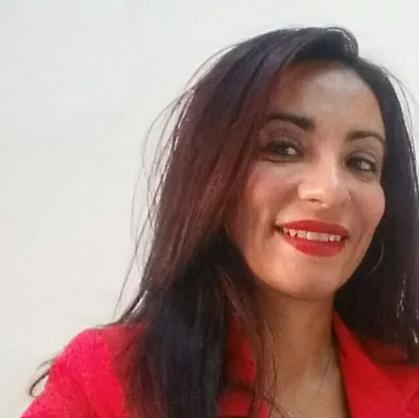 | Anna Barbaro is a Senior Lecturer in Forensic Biology, Genetics, and Forensic Medicine in university and postgraduate courses in Italy, Spain, Colombia, Bolivia, and Malta. She served as Director of the Forensic Genetics Department at SIMEF (Italy), consultant for Italian courts, and researcher at the University of Alcalá (Spain). She holds a PhD in Forensic Genetics and multiple postgraduate diplomas in applied genetics, criminal investigation, crime scene investigation, and criminalistics. President of the Worldwide Association of Women Forensic Experts (WAWFE), she consults for the EU Research Executive Agency and Spain’s ENAC.  She authored 200+ papers, edited 5 forensic manuals, and received numerous awards.
Peter Parkinson  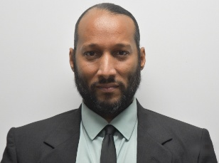 | Peter A. Parkinson is the Chief Crime Scene Examiner and head of the Forensic Department at the Independent Commission of Investigations (INDECOM) with expertise in Blood Spatter Analysis; Crime Scene Management as well as Shooting Reconstruction with over fourteen (14) years of experience. He is also a trained Forensic Scientist proficient in the areas of Biological and DNA analysis with over three and a half years of experience at the Jamaica Constabulary Force Forensic Science Laboratory (Biology Department) now the Institute of Forensic Science and Legal Medicine (IFSLM).  His professional qualifications include a Master’s degree in Forensic Science (M.Sc.), with special emphasis in Biology, from the University of Strathclyde, Glasgow, Scotland as well as certification as a Crime Scene Analyst from the International Association for Identification (IAI). He believes that as Forensic Practitioners excellence in our duties should be fueled by our passion for knowledge, truth and justice.
Natalia Gutierrez  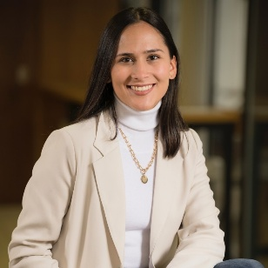 | Natalia Gutierrez is the Business Development Manager at Smytec. With over five years of experience in strategy and planning within South America’s steel industry, Natalia has relocated to the UK, where she supports Smytec’s international growth. She leads a customer-focused strategy, developing both existing and new market segments while aligning marketing efforts to build strong brand awareness.  Natalia holds a degree in Marketing and Finance, as well as an MBA from Warwick Business School.
Ricardo Wilson  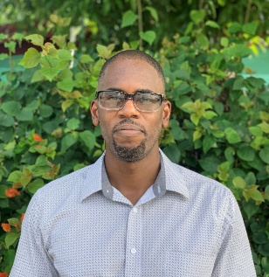 | Ricardo Wilson is a Senior Scientist at the New Zealand Institute of Public Health and Forensic Science. His work involves technical support to forensic laboratories that have transitioned to probabilistic genotyping platforms, providing training support to scientists, as well as research. Ricardo possesses over fourteen years of casework experience in the discipline of forensic biology. During his tenure at the Institute of Forensic Science and Legal Medicine in Jamaica, he has had the opportunity to lead DNA method and platform validations while also gaining invaluable casework exposure as an analyst. He holds a Master’s degree, with distinction from the University of the West Indies in Forensic Science. On his off days, Ricardo enjoys watching football and spending time with family.
Alyssa Moss  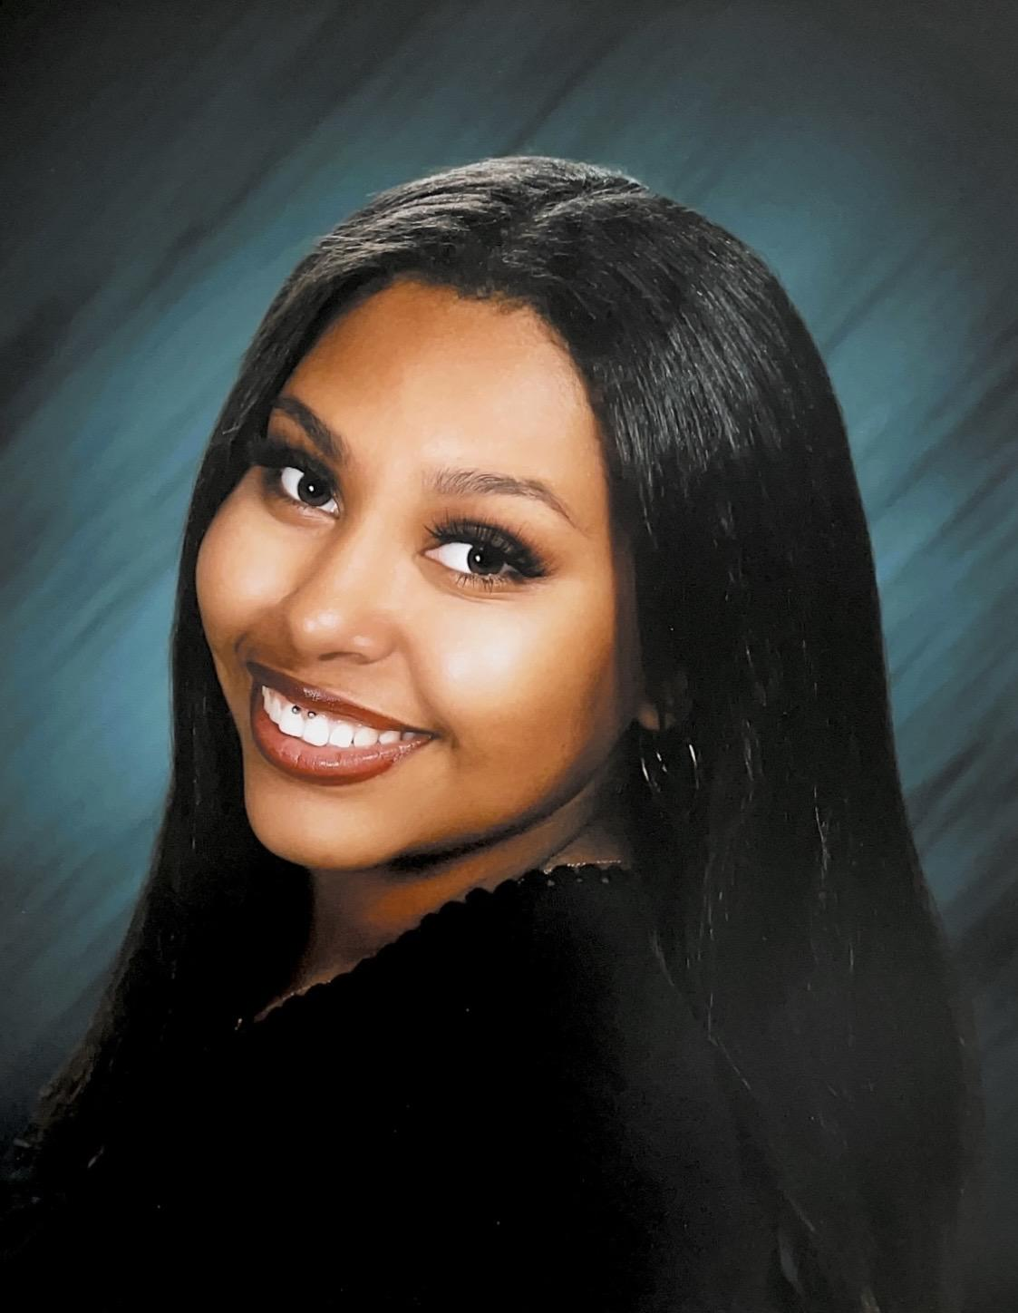 | Alyssa Moss-Garcia is a third year undergraduate student currently attending Cal State San Marcos with a Criminal Justice Studies major. She also graduated from Imperial Valley College with an Associate’s Degree in Administration of Justice with a concentration in General Sciences. Alyssa has developed a strong interest in forensic science and has long aspired to become a medical examiner from a young age. Her fascination with the field comes from her desire to understand the science behind investigations and to fuel her drive in the criminology field. She has participated in the Upward Bound Federal program in high school that aids students in earning college credits at a university, and was a Student Support Services mentor at Imperial Valley College, helping students in course selections and tutoring support. Moss-Garcia is also certified in Google Cybersecurity and AI Literacy which both aid in online safety, problem-solving, and how artificial intelligence is shaping our future. Moss-Garcia is deeply committed to serving her community and protecting the environment. She has volunteered at a turtle sanctuary, Pachamama Ranch in Dulzura, California, where she helped care for and protect wildlife habitats and enclosures. Alyssa is equally passionate about helping those in need and has volunteered with Las Hormigas de Jesus, a non-profit organization located in the Imperial Valley, assisting in feeding and supporting homeless individuals within her community throughout Southeastern California. Originally from Calexico, California, Moss-Garcia is passionate about learning, growth, and building a successful future for not only herself, but her community as well.
Dionne A. Cruickshank  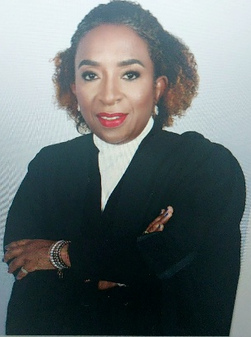 | A qualified Attorney-at-law, earned her Bachelor of Laws in 2000 at the London Southbank University, in London England. She was then admitted to the Bar of England and Wales at Inner Temple in 2004 and the Bar of Jamaica in 2005. Dionne is a Graduate of Florida Atlantic University, in Palm Beach Florida where she was awarded a Bachelor of Arts Degree majoring in English in 1994. Dionne obtained Qualified Teacher Status for England from Greenwich University in 2003 and holds a Post Graduate Qualification in Forensic Science Focusing on Crime Scene Investigation from the University of the West Indies in 2023. Dionne will be awarded a Master of Law in Legal Practice Research from Nottingham Trent University, in the England in July 2026, where she researched the Application of Artificial Intelligence in the area of Criminal Law. Her areas of Practice is Criminal and Family and currently employed as a Legal Clinician, wherein she teaches students the practice of Law at the Norman Manley Law School Legal Aid Clinic, in Kingston Jamaica; additionally, she is an adjunct lecturer delivering the module for Legal and Ethical Issues in Forensic Science at University of Technology University of the West Indies, Mona Campus on the Post Graduate Program.  (Publications, Elgar Concise Encyclopedia of Legal Education: Client Interviewing in Legal Education and Life at the Bar in Jamaica. Inner Temple Yearbook 2023.)  Dionne has a lifelong interest in clinical and experiential legal education with a focus in Criminal Law and Forensic Science, Ethics and Technology specifically Artificial Intelligence and Emotional Well-being. Dionne has participated in numerous conferences seminar and workshops and presented papers, at The Jamaica Bar Association Conference, Department of Public Prosecution Empowerment Workshop, Kingston Jamaica, Institute for Education Administration leadership- Conference Montego Bay, Jamaica, Caribbean Association of Forensic Science Kingston Jamaica, Association of Law Teachers in England and Wales. Dionne is a member of the Inner Temple (England and Wales), Jamaica Bar Association, Advocates Association, Jamaica. Dionne is an executive member of the Caribbean Association of Forensic Science and sits on their executive body as a Trustee and is an Executive Member of the Association for Law Teachers in England and Wales. Dionne’s enjoys travelling, reading and writing and farming. She is an active member of the Church of England (Anglican Diocese in Jamaica). She is also a member of the Jamaica Artificial Intelligence Association.
Hillary Mullings-Williams  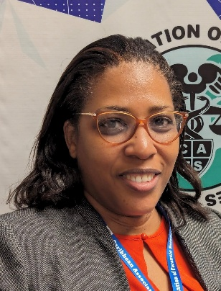 | Hillary A. Mullings-Williams is a Jamaican forensic science practitioner with more than two decades of experience at the Institute of Forensic Science and Legal Medicine in Kingston, Jamaica. Since 2009, she has served as Chief Forensic Science Officer in the Biology Department, overseeing serological analyses, crime scene examinations, quality systems, research, and staff training. She has frequently provided expert witness testimony and technical guidance to law enforcement and the judiciary.  Mrs. Mullings-Williams holds an MSc in Forensic Science (Merit) from Staffordshire University, a BSc (Hons) in Zoology, and a Postgraduate Certificate in University Teaching and Learning from The University of the West Indies, Mona. She is trained in bloodstain pattern analysis, ISO/IEC 17025, internal auditing, corrective actions, leadership, microscopy, project management, and advanced crime scene and fingerprinting techniques.  An active educator, she lectures in forensic serology and trace evidence at UWI Mona, serves as an Assistant Professor of Forensic Science at Northern Caribbean University, and is an Adjunct Lecturer at the Caribbean Maritime University. Regionally and internationally engaged, she is a founding member and Secretary of the Caribbean Association of Forensic Science, a member of the International Association for Identification, and the Caribbean Coordinator for the Worldwide Association of Women Forensic Experts. She has presented at major international conferences and authored Chapter 14, Trace Evidence, in the book Manual of Crime Scene Investigation (CRC Press, 2022), helping advance forensic science practice and education across the Caribbean.
Camelia Larmond | Camelia Larmond was called to the Jamaican Bar in December 2015 and has spent her entire legal career thus far in the Government Service. Ms. Larmond has acquired over 9 years of legal experience and has made representations on behalf of the prosecution in all the Courts of the island. She first assumed the role of Judicial Clerk at the Supreme Court of Jamaica. Later, Ms. Larmond moved to become the Clerk of Court for the Parish of Manchester. When her time was spent, she was transferred to the Office of the Director of Public Prosecutions where she assumed duties as Crown Counsel. At present, Ms. Larmond is the Legal Counsel attached to the Ministry of National Security.  Personally, Ms. Larmond enjoys public speaking, reading and is a dedicated mother. She is pro team work, dedicated and a meticulous individual who embodies service above self.
Danielle Black  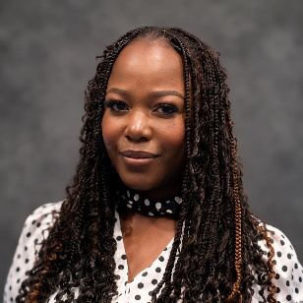 | Danielle Black is a postgraduate student at The University of the West Indies, pursuing a Master of Science degree in Forensic Science with a specialization in Molecular Biology. She is a recipient of the 2025 Marcus Garvey Scholarship, awarded in recognition of her academic excellence and potential. As part of her master's research, Danielle is investigating the effects of biological and non-biological laundry detergents commonly used in Jamaica on the persistence and detection of protein markers from blood and saliva stains on different fabrics, with implications for forensic evidence recovery and interpretation. Danielle is also employed at the Institute of Forensic Science and Legal Medicine, where she has served for six years, contributing to the efficient operation and high-volume workflow of her department. Her professional and research interests include forensic biology, forensic serology, and molecular approaches to forensic evidence analysis.
Nicola Brown-Baxter  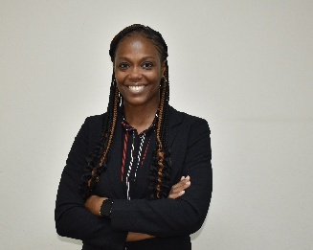 | Nicola Brown-Baxter is a Government Analyst at the Institute of Forensic Science and Legal Medicine where she coordinates and supervises the analysis of exhibits for forensic evidence. She has served as a Government Analyst for over twenty (20) years and assists in ensuring the smooth operation of the Chemistry Department daily.  Mrs. Brown-Baxter holds a BSc (Hons) in Chemistry and Applied Chemistry from the University of the West Indies and a master’s degree in Forensic Science from King’s College, University of London. Additionally, she has participated in and completed extensive training in various areas of forensic science to include: high resolution mass spectrometry for forensic toxicology, fire investigations, post blast investigation and explosives, blood pattern analysis and analytical skills development.  She is a member of The International Association of Forensic Toxicologists (TIAFT) and the National Association of Fire Investigators (NAFI). During her tenure at the Forensic Institute, Mrs. Brown-Baxter has served as a guest lecturer at the University of the West Indies, the Justice Training Institute and the Caribbean Regional Drug Law Enforcement Training Centre (REDTRAC).  Outside of work, Mrs. Baxter enjoys reading and listening to retro music.
Gavin Palmer  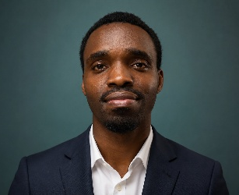 | Gavin Palmer is a Forensic Science Officer in the Chemistry Department at the Institute of Forensic Science and Legal Medicine (IFSLM), in Jamaica. He has been employed at the institute for over 10 years and specializes in the examination, identification, and chemical analysis of controlled substances as well as toxicological evidence for criminal investigations and judicial proceedings. He has a Bachelor of Science in Applied Science (specialize in Forensic Chemistry) from the University of Technology, Jamaica. This has equipped him with the basic knowledge of Chemical and Toxicological analysis, as well as Analytical and Medicinal Chemistry. His duties at IFSLM includes processing various exhibits, research, preliminary and confirmatory analyses using microscopy, color tests, thin layer chromatography (TLC) and instrumentation via gas chromatography–mass spectrometry (GC-MS), LC-QToF and GC-FID; interpreting analytical data; and preparing formal forensic reports.
Keadien S. Reid  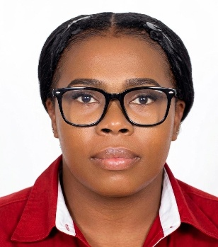 | Keadien S. Reid is an emerging forensic science scholar with a strong academic background and expertise in forensic analytical chemistry. She earned a B.Sc. in Applied Science with a focus on Forensic Chemistry from the University of Technology, Jamaica, gaining skills in forensic analysis, chromatography, spectrometry, quantitative methods, and lab practices.  Currently, she is working as a Crime Scene Examiner at the Independent Commission of Investigations and pursuing a M.Sc. in Forensic Science at the University of the West Indies. Her research uses advanced tools like mass spectrometry and gas chromatography to study forensic toxicology, trace evidence such as fibers and glass, and the interpretation of complex evidence.  Beyond academics, Ms. Reid is the President of the Forensic Science Students’ Association and Student Representative for the Caribbean Association of Forensic Science. She organizes workshops, promotes peer engagement, and advocates for professional development, emphasizing collaboration, ethics, and high standards.  She aims to improve forensic practices in Jamaica and the Caribbean, with future plans to focus on forensic analytical chemistry and crime scene examination to enhance forensic methods and justice outcomes.

